# 成绩构成

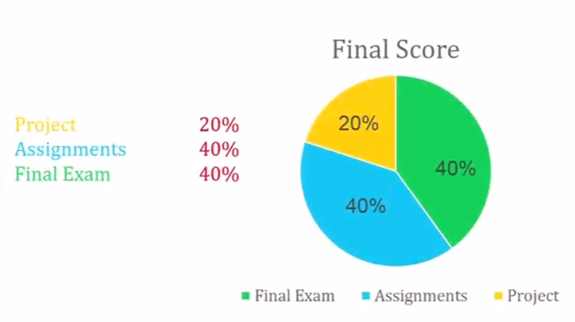

image-20220829141950031

* 项目 20%
* 作业 40%
* 期末 40%

# 课程大纲

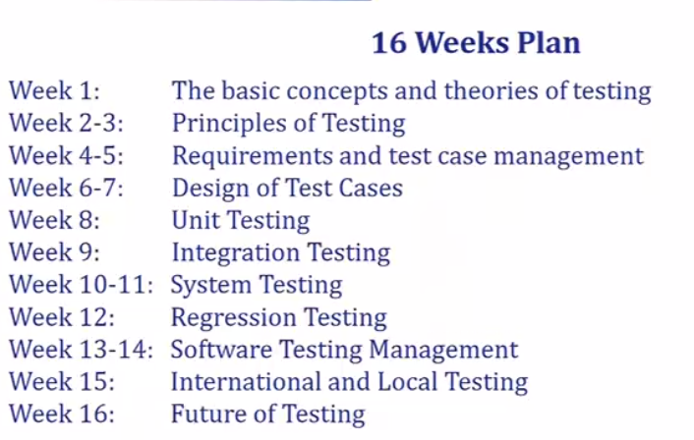

image-20220829142148079

**第4-5周，6-7,重要，8非常重要**

# 参考文献

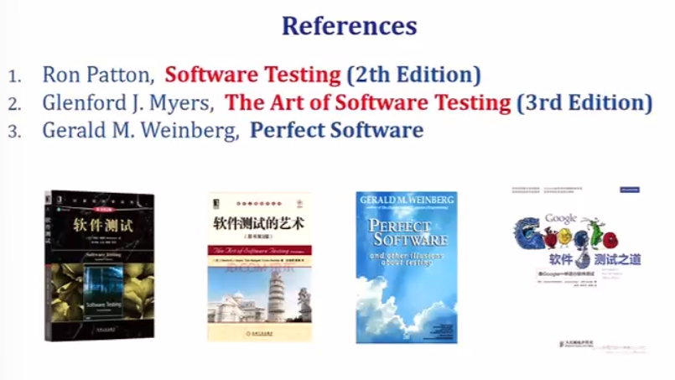

image-20220829142242059

软件测试Ron Patton, Software Testing(2th Edition)

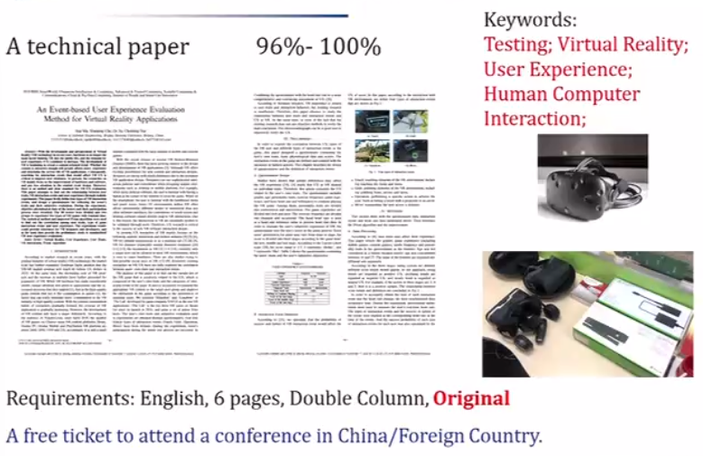

image-20220829142525769

# 1. The basic concepts and theories of testing

## Software testing

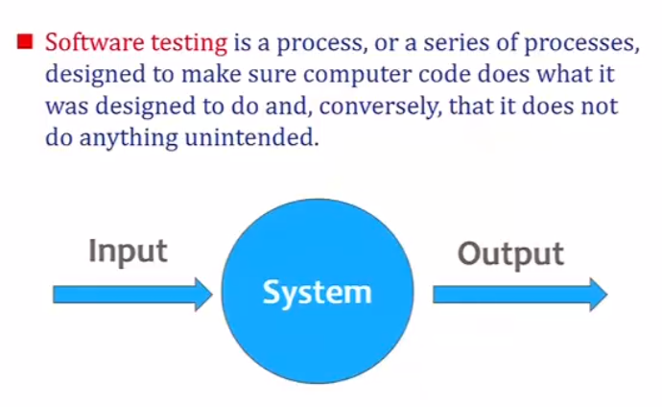

image-20220829142804297

## Test Cycle

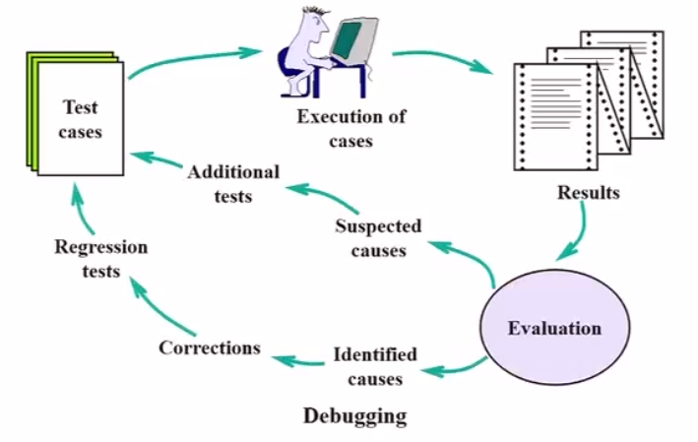

image-20220829143127177

**测试用例不断更新**

## 测试分三个维度

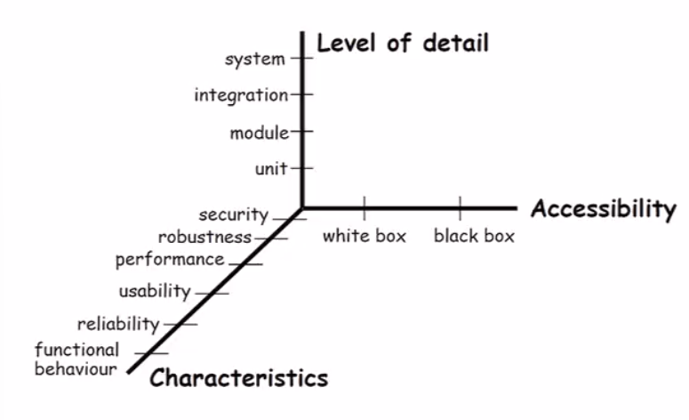

image-20220829143613011

**grey box** between black and white box

unit - white box  
system - black box

## Fault, Error & Failure

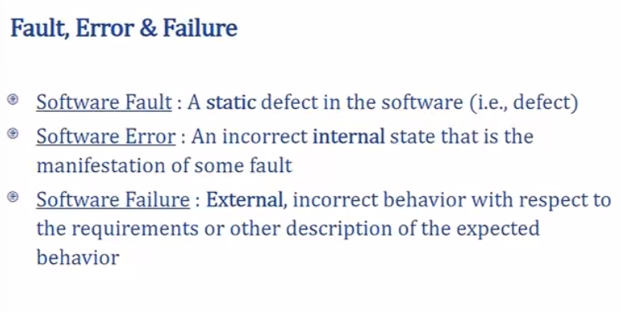

image-20220829152127218

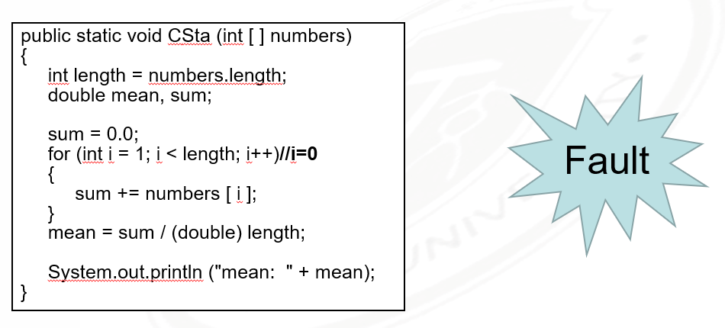

image-20220905143942298

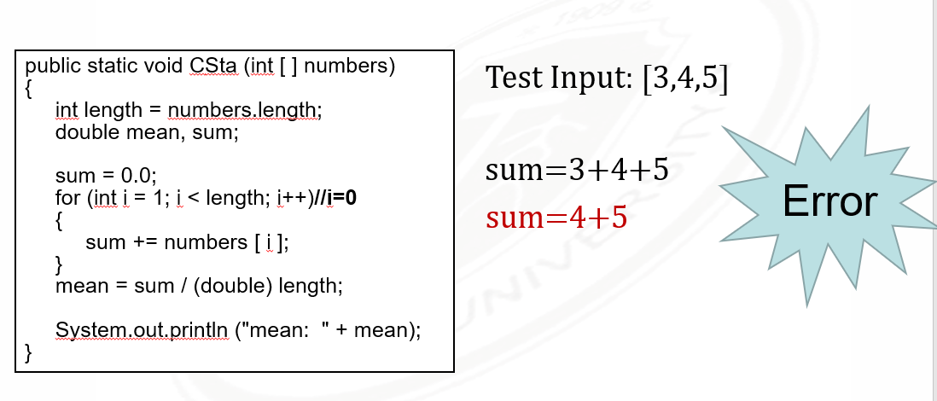

image-20220905143954757

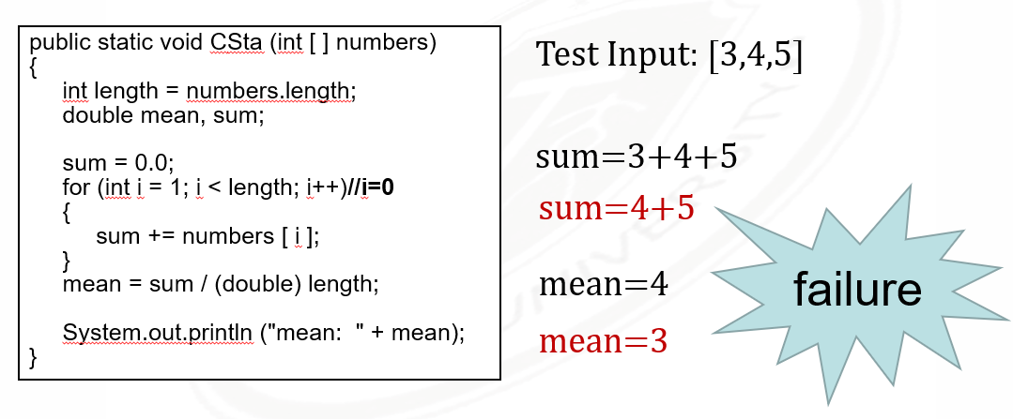

image-20220905144007087

# 2. Principle of Testing

**Source of Problems:**

* **Requirements Definition:** Erroneous, incomplete, inconsistent requirements.
* **Design:** Fundamental design flaws in the software.
* **Implementation:** Mistakes in chip fabrication, wiring, programming faults, malicious code.
* **Support System:** Poor programming languages, faulty compilers and debuggers ,misleading development tools.
* **Inadequate Testing of Software**: Incomplete testing, poor verification, mistakes in debugging.
* **Evolution:** Sloppy redevelopment or maintenance, introduction of new flaws in attempts to fix old flaws, incremental escalation to inordinate complexity.
* **Communications:** Loss or corruption of communication media, non delivery of data.
* **Space Applications:** Lost lives, launch delays.
* **Defense and Warfare:** Misidentification of friend or foe.

**测试流程**

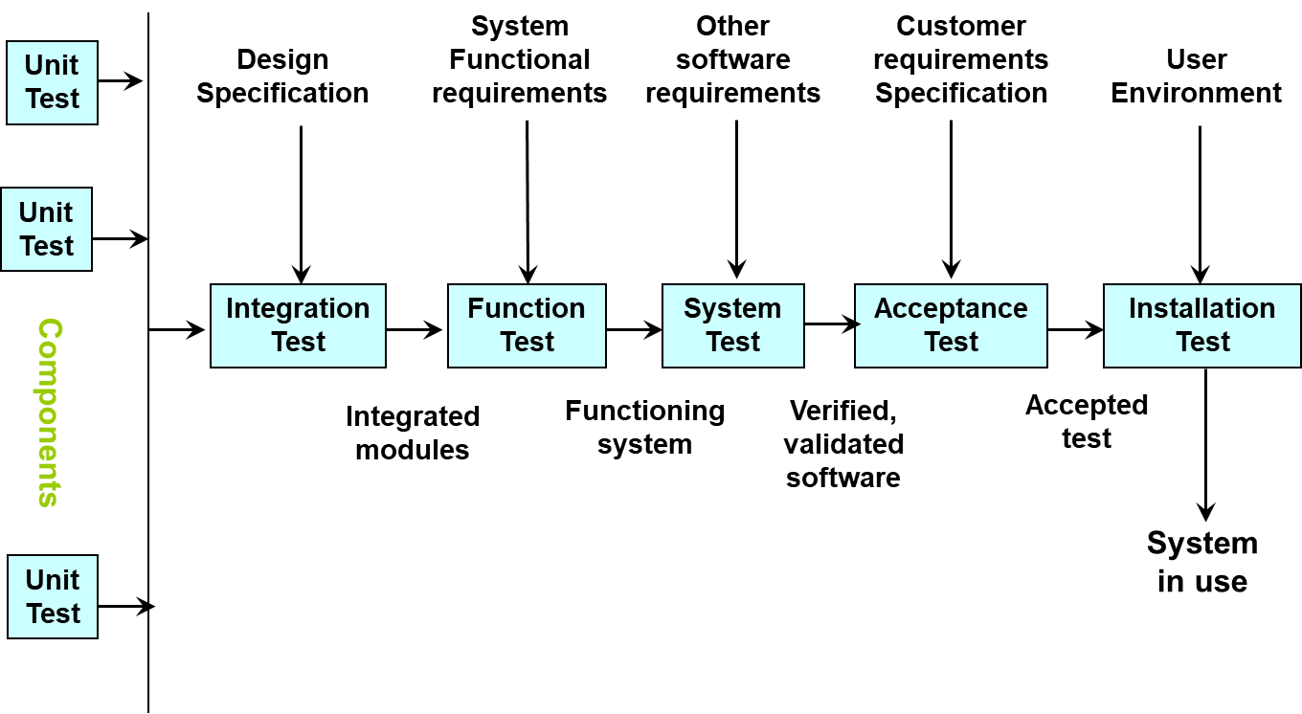

image-20220907103241190

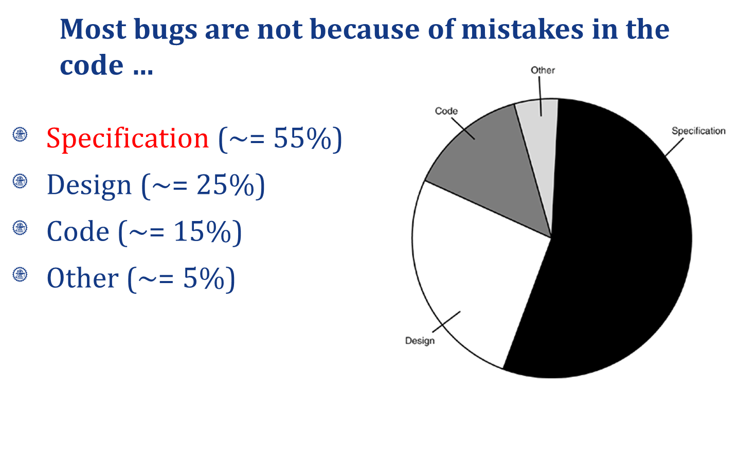

image-20220907104843604

**Goal of a software tester：**

* ... to find bugs
* ... as early in the software development processes as possible
* ... and make sure they get fixed

**BRD** - Business requirement document  
**MRD** - Market requirement document  
**PRD** - Program requirement document

* Customer requirements  
  The software development team must determine what the customer wants.
* Specification
  + The specification takes the data from the customer requirements and other sources and defines:
    - **The features of the software** (functional requirements).
    - **The constraints on these features** (non-functional requirements).
  + Specifications can be:
    - **formal**, rigid
    - **informal**, on a cocktail napkin or a whiteboard

Testing - 找  
Debugging - 修  
Verification - 文档  
Validation - 用户

# 3. White Box

Examine the Design Document & Code **static**

**Control Flow**

控制流:

* Statement testing
* Branch testing
* Path testing

数据流:

* Definition-use path testing
* All uses testing

## 控制流

Example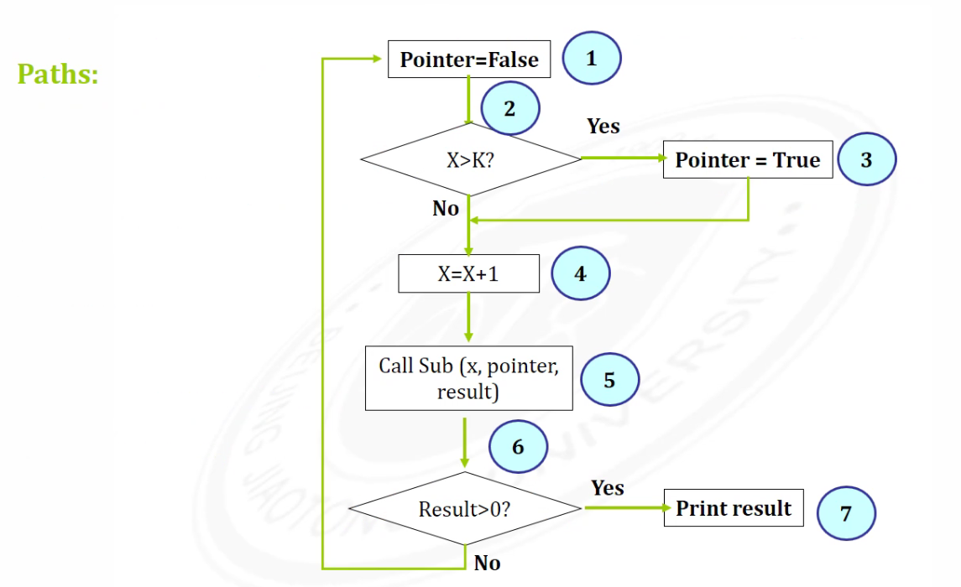

### **Basic Path Testing**

cyclomatic complexity 圈复杂度->图越复杂->程序越复杂

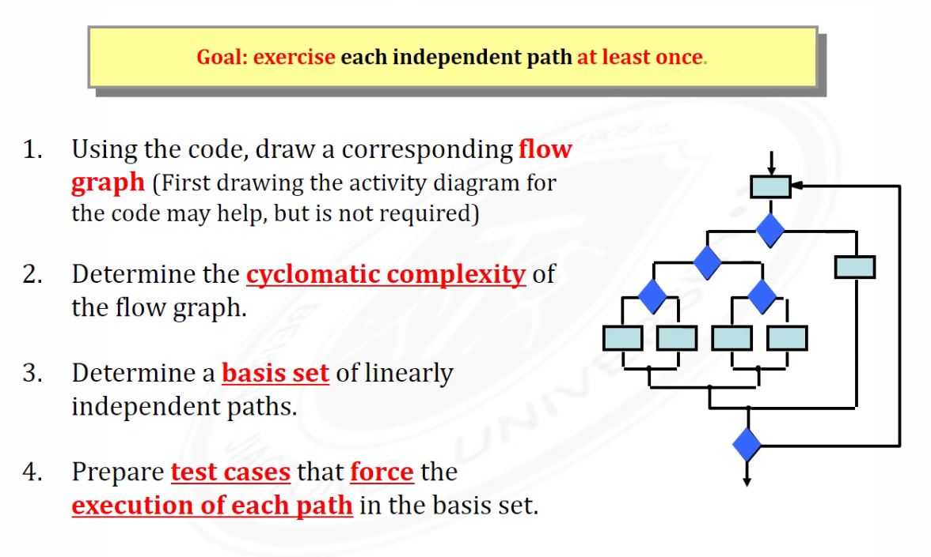

image-20220919145050840

* Decision
* Junction
* End

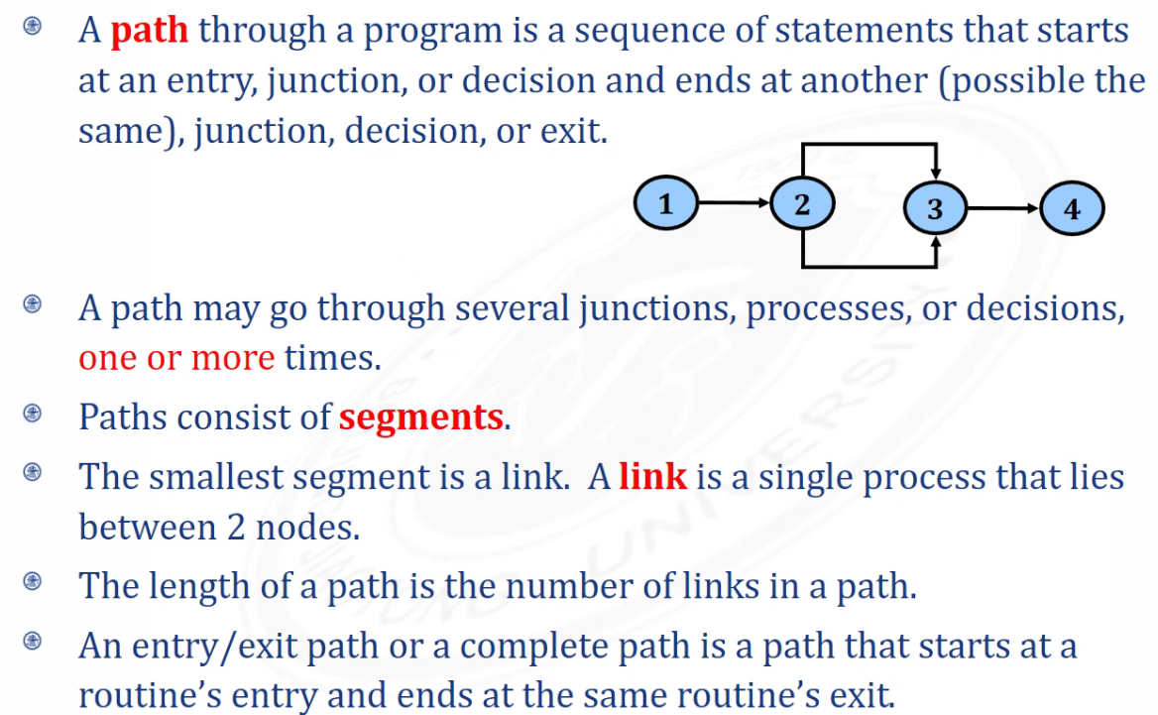

image-20220919145853454

**圈复杂度计算**

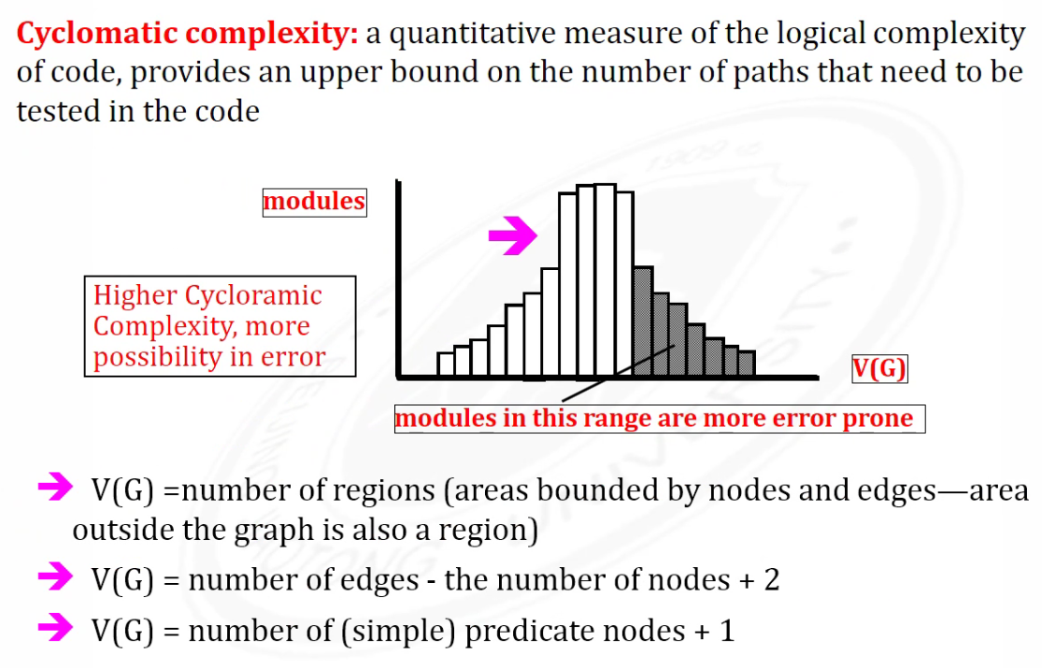

image-20220919151321035

* 区域
* 边-节点+2

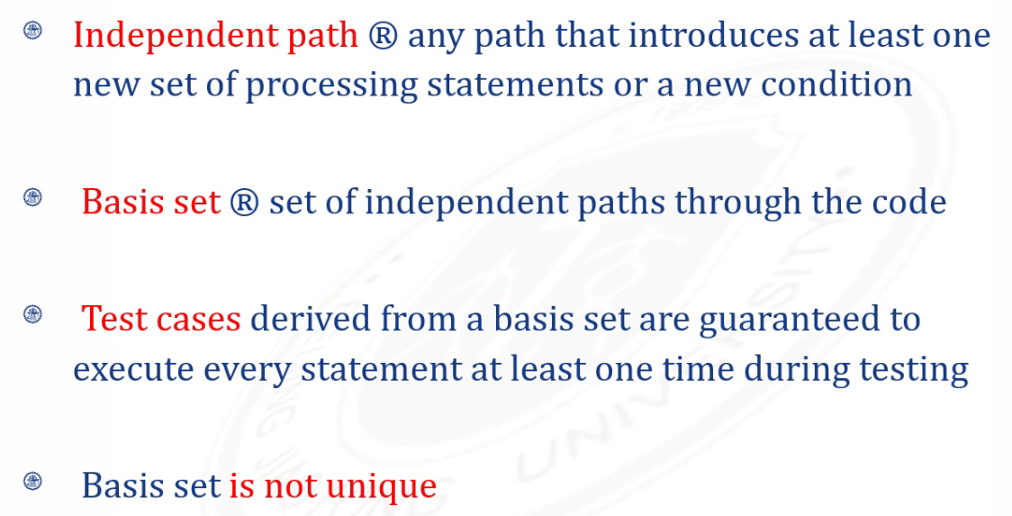

image-20220919151810288

V(G)= the number of Independent path

**Not complete Testing:**

* Spec
* Testcases
* Not all bugs can be fixed

### Condition testing

**Logical conditions**

* Simple condition: (a rel-op b) where rel-op={<, ≤, =, ≠, ≥, >} (may be negated with NOT), e.g., a≤b; NOT(a≤b)
* Compound condition: two or more simple conditions connected with AND, OR, e.g., (a>b) AND (c<d)
* Relational expression: (E1 rel-op E2) where E1 and E2 are arithmetic expressions, e.g., ((a*b+c)>(a+b+c))

**Branch testing**

for a compound condition C, test true and false branches of C and every simple condition of C

e.g., for **C** = (**a>b**) AND (**c<d**) test:

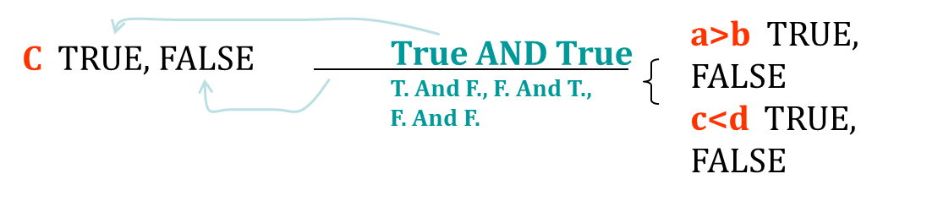

image-20220921111739543

**Domain testing**

for an expression **E1 rel-op E2**, test for E1 **≧ ≦ = < > ≠** E2

* guarantees detection of rel-op error if E1 and E2 are correct
* to detect errors in E1 / E2, the difference between E1 and E2 for the tests E1 **<** or **>** than E2 should be as small as possible
* for an expression with n variables, 2n tests are required

**Coverage**

* condition coverage
* preserves desicion coverage:  
  decision/condition coverage

path coverage 最大

* Path Testing Pu
  + 100% path coverage.
  + Execute all possible control flow paths through the program.
* Statement Testing P1
  + 100% statement coverage.
  + Execute all statements in a program at least once under some test.
* Branch Testing P2
  + 100% branch coverage.
  + Execute enough tests to assure that every branch alternative has been exercised at least once under some test.

P1 ≤ P2 ≤ Pu

## 数据流(考试无关)

**Definition**

A location where a value for a variable is stored into memory

**def and use**

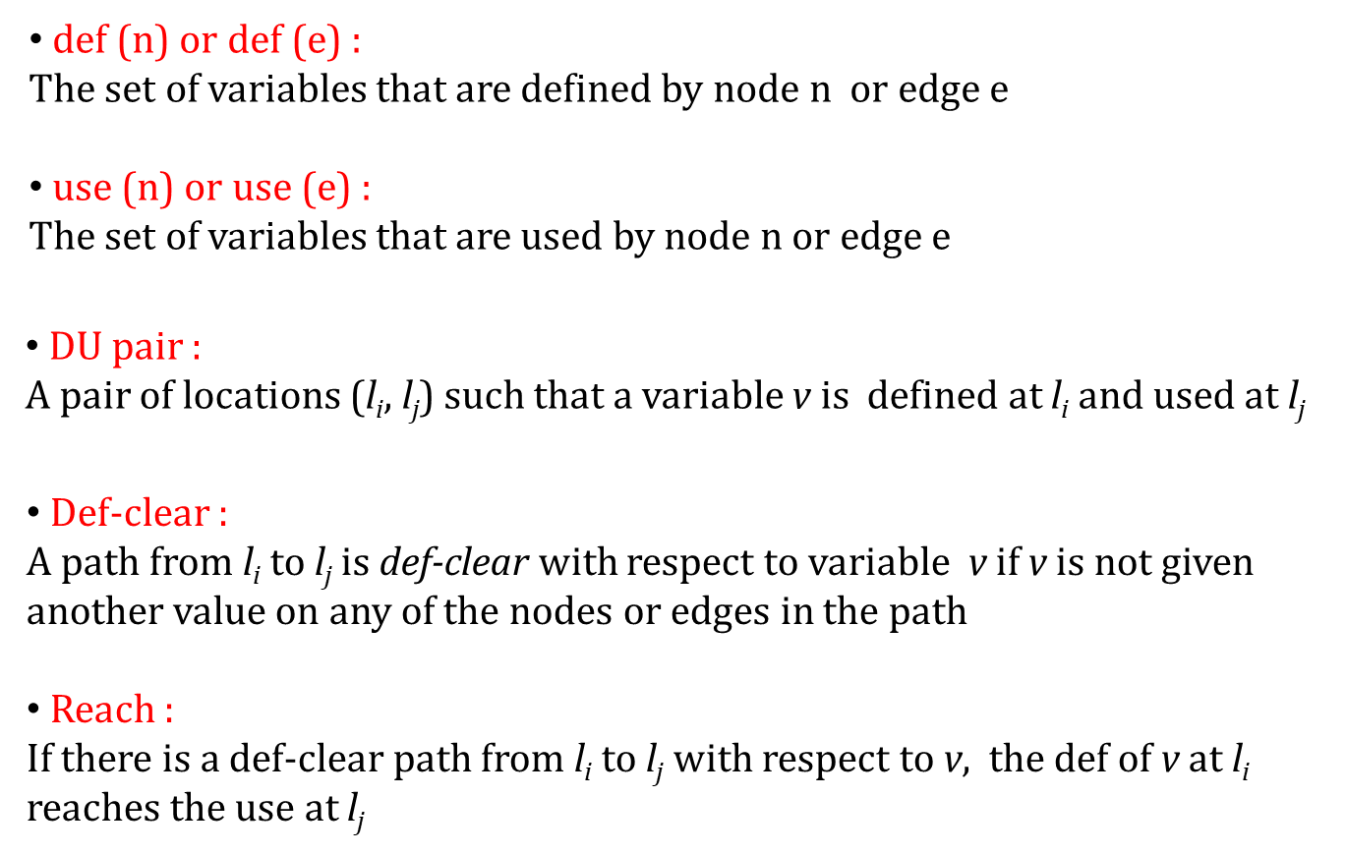

image-20220921120211567

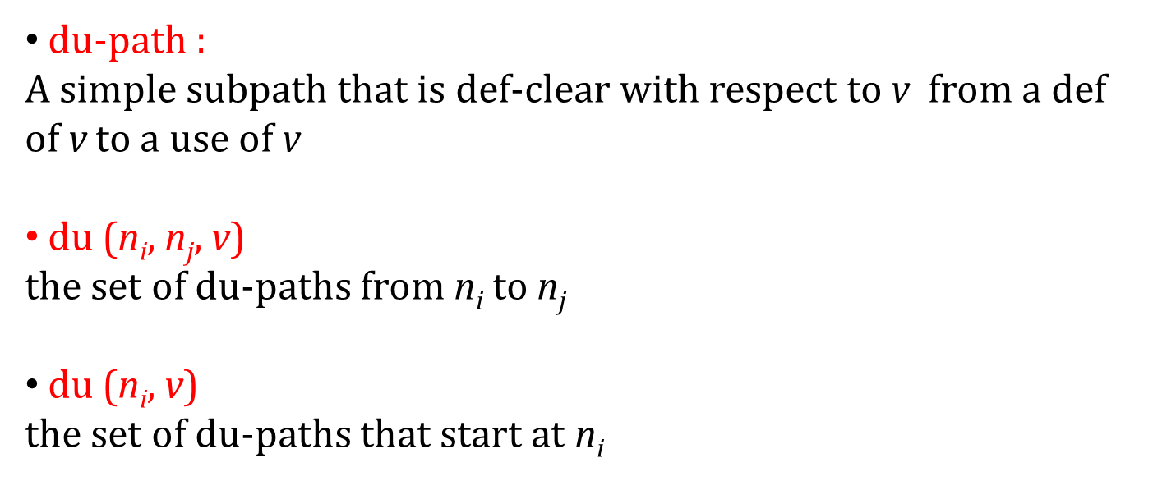

image-20220921120238133

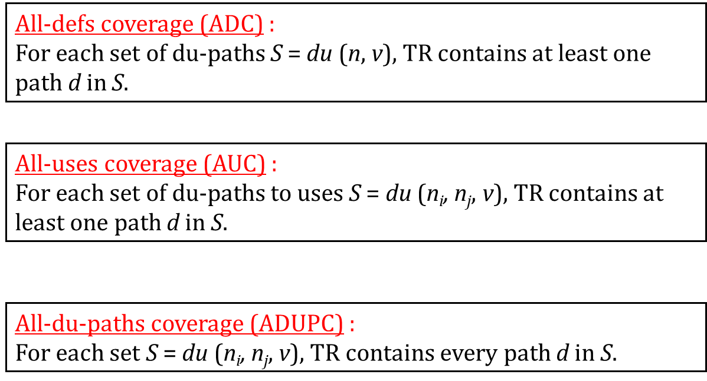

image-20220921120255897

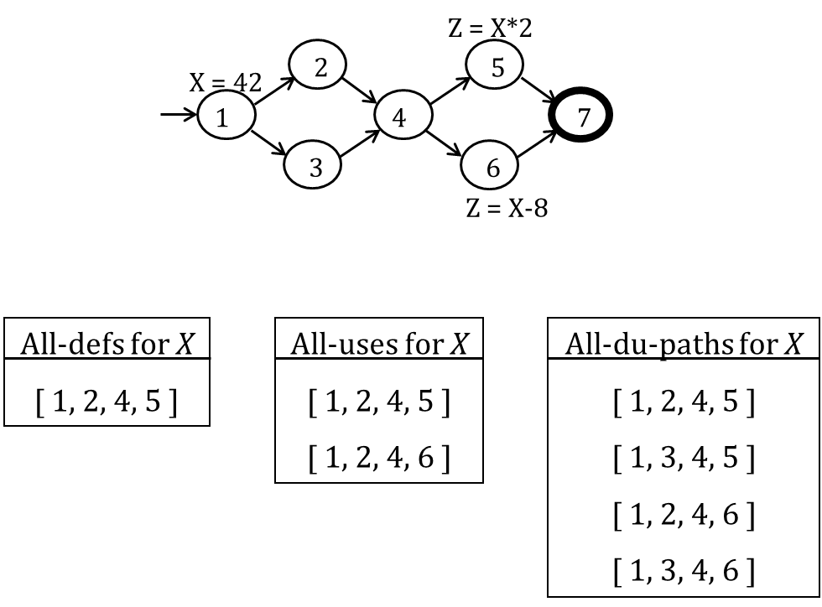

image-20220921120431612

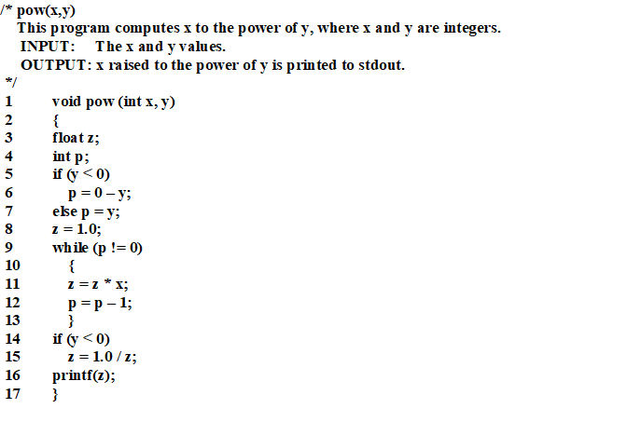

image-20220926142226990

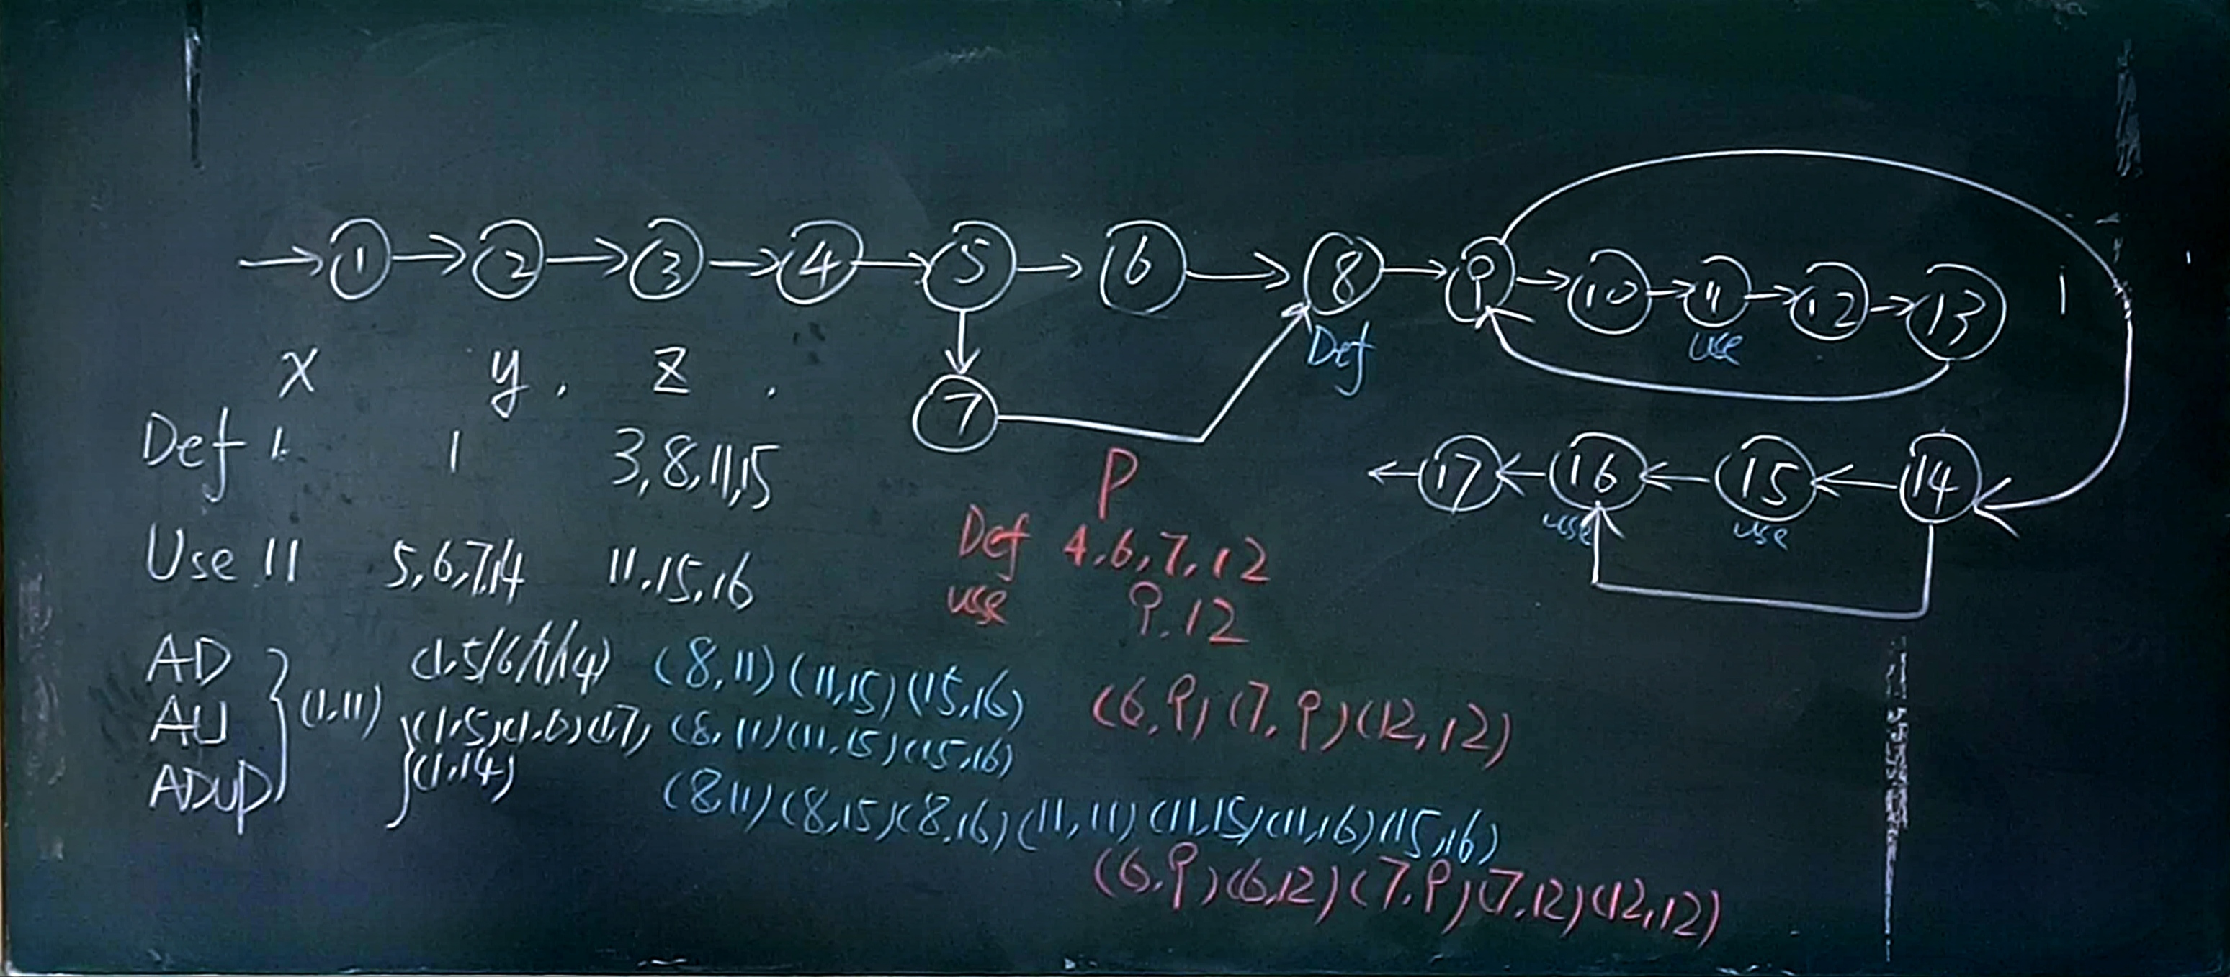

image-20220926143250503

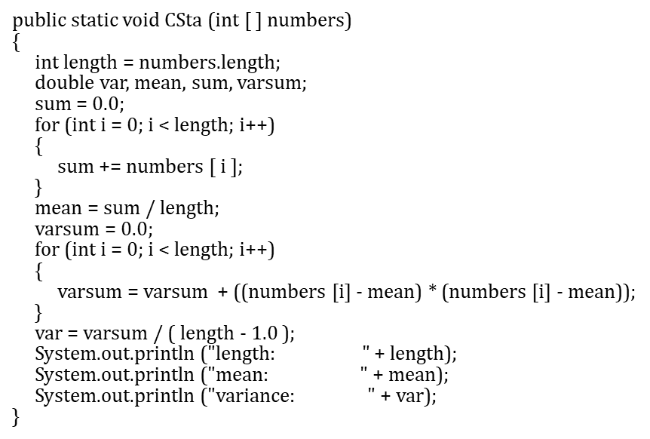

image-20220926144846685

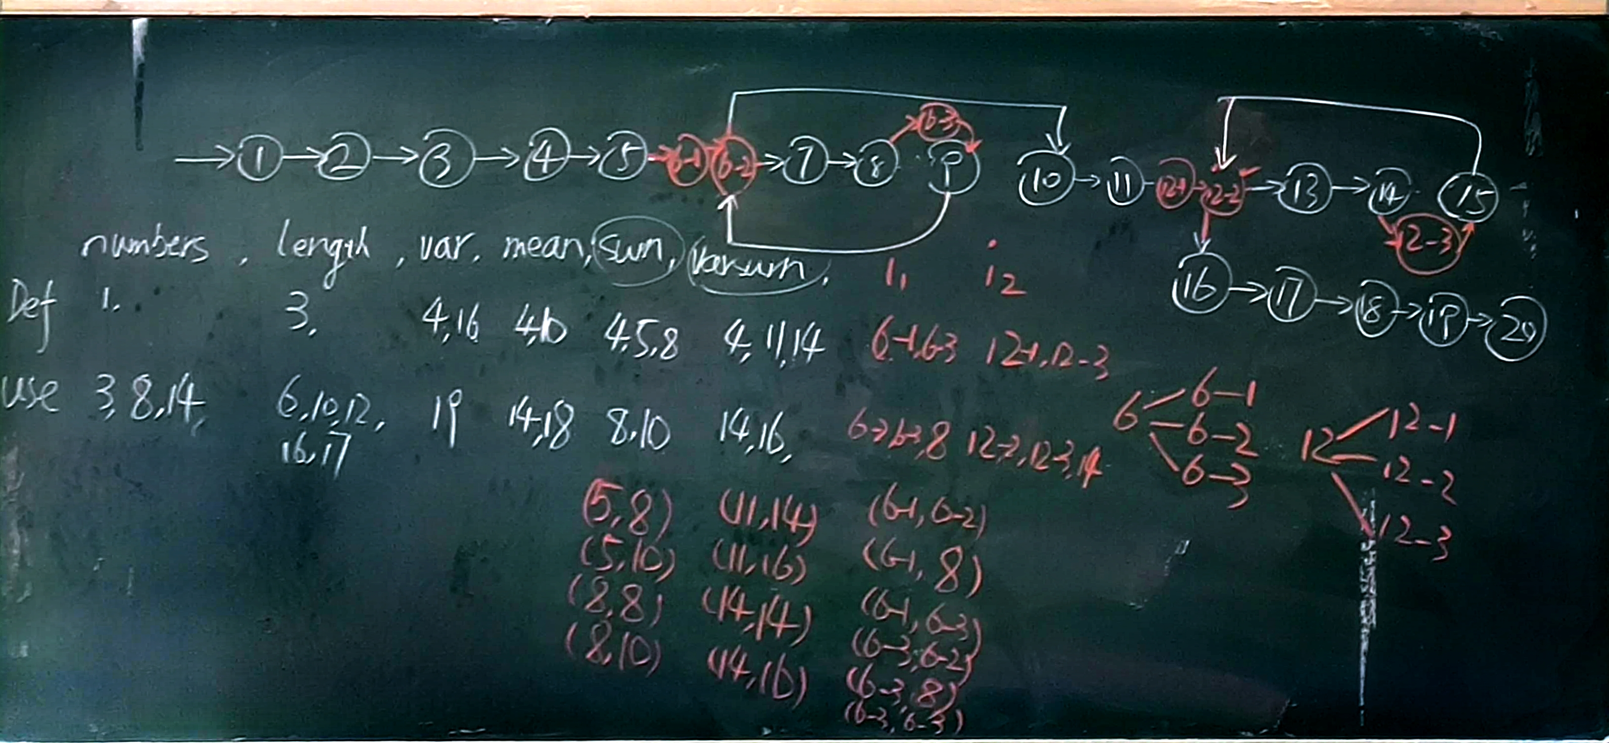

image-20220926150000546

**数据流必须全拆，控制流有些可不拆（并行判断要拆）**

# 4. Black Box

Test case:

1. Reduce Testcase
2. Maintain Test Performance
3. Test Coverage

## 4.1 Random Testing

Adaptive Random Testing 选点有规则且与前几个用例越来越远

## 4.2 Equivalence Partitioning

Identify input equivalence classes注意边界值:

* Based on conditions on inputs/outputs in specification/description: Both valid and invalid input equivalence classes
* Based on heuristics and experience  
  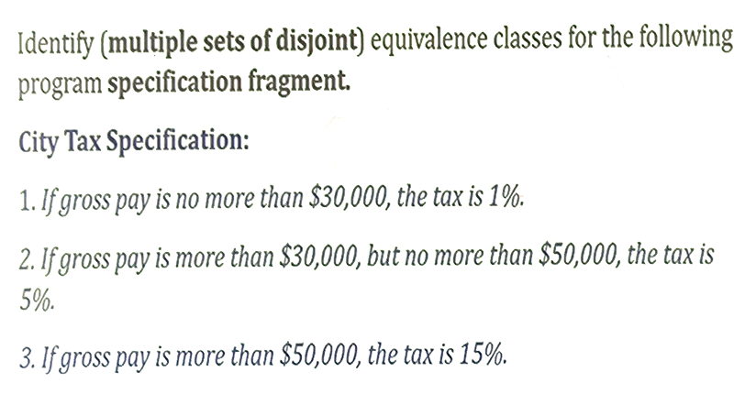  
  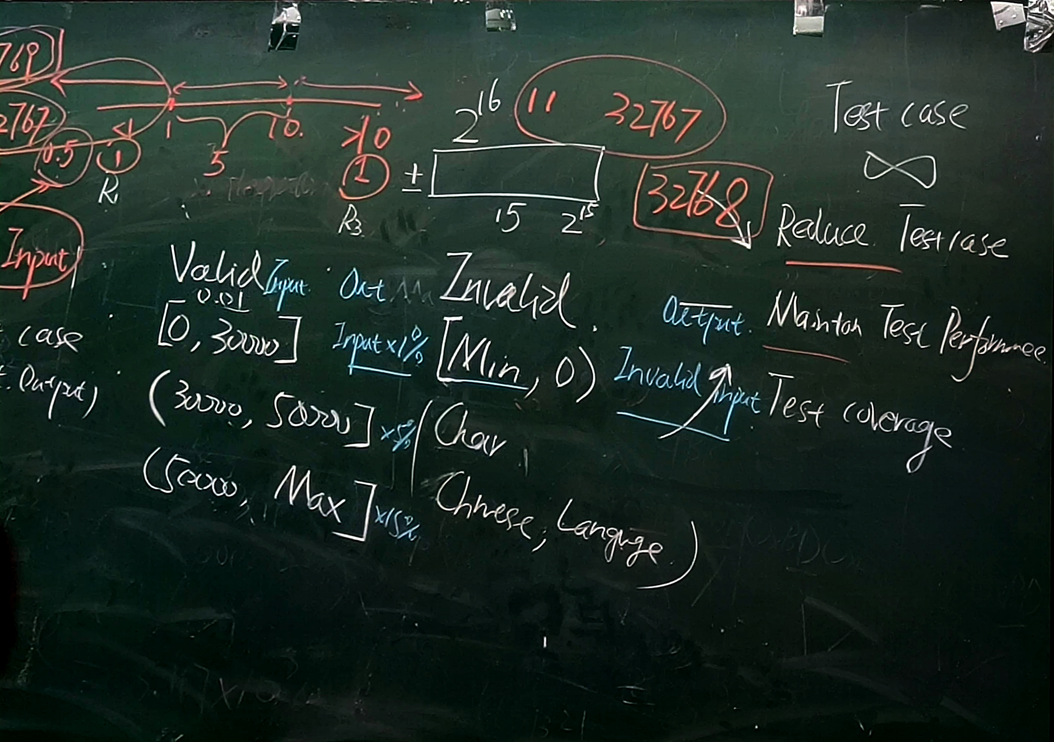

## 4.3 Boundary Value Analysis

**Example strategy as extension of equivalence partitioning:**

* choose one (n) **arbitrary** value(s) in each eq. class **每个class选个任意值**
* choose values **exactly** on **lower /upper boundaries** of eq. class **准确值**
* choose values **immediately** below /above each boundary ( if applicable ) **临界值** min和max也都要测 （min - 1可放在class中）

## 4.4 Cause Effect Analysis

因果分析

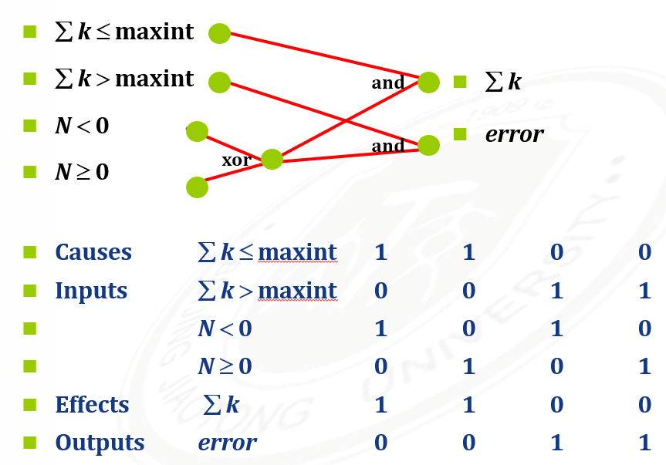

image-20221010155456390

RT  
ART - Reduce test case  
EP - Reduce test case & maintain test performance  
BVA - Maintain test performance & Coverage  
Cause Effect - Reduce Test case